Case Study: Covid-19 Second Vaccination with Continuous Temperature Monitoring in Two Patients

COVID-19 vaccination helps protect the public. Some people may have side effects, which are normal signs that their body is building protection. The most common symptoms are injection site pain, headaches, flu-like symptoms, fever, and tiredness. These potential side effects may affect abilities to do daily activities, but they usually go away in a few days. Side effects after the second shot may be more intense than the ones experienced after the first vaccination shot.

Additionally, many now have questions about ‘next-steps’ for adults who received their first vaccination dose of the Oxford-AstraZeneca vaccine. A study was published in The Lancet on May 12, 2021, reporting that adults 50 and older who received doses of both the Oxford-AstraZeneca and Pfizer/BioNTech COVID-19 vaccines reported more mild and moderate side effects than those given only one type of two-dose vaccine. According to this study, the groups receiving two different vaccines had more systemic reactions after the second dose than after the first, the most common of which was fever.

TempTraq is a new Continuous, Real-Time Body Temperature Monitoring System that uses a 72-Hour Patch enabled with Bluetooth. TempTraq is an FDA Cleared, Health Canada registered Class II medical device that gives Healthcare providers the first wireless continuous temperature monitor in the form of a soft, comfortable, disposable patch. TempTraq can significantly improve the way temperature is measured in the clinical environment and provide clinicians a quicker, easier, and more effective way to measure temperature in hospital or remotely from patient’s homes.

In the TempTraq temperature patch recording below, the patient receiving their 2nd Covid 19 vaccination (Moderna-NIAID). We can see a change in body temperature, rising from ‘normal’ GREEN (38.0°C), through ORANGE (> 38.0°C) to RED (equal to, or higher than the ‘alert’ temperature set for that patient), from 12 noon through 6pm.

The patient was symptomatic, consistent with post Covid 19 vaccinations reported by patients of flu like symptoms. This individual took Tylenol in response their ongoing fever at 6:00 pm. From the graph below, we can see this medication did help return the individual’s temperature to the ‘GREEN’ (at, or below 38.0°C). The patient’s body temperatures did not rise for the remainder of the 72-hour temperature surveillance on the TempTraq patch.
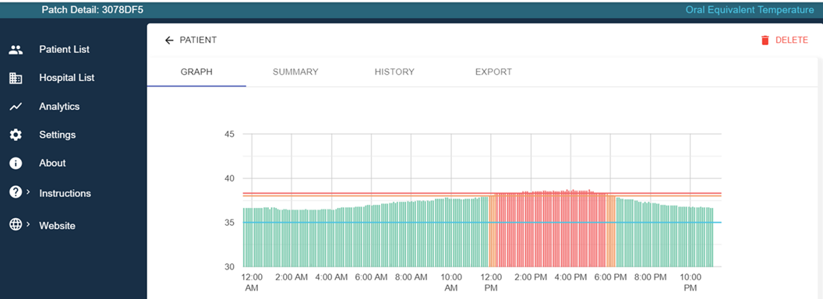

In the second case we can see from the TempTraq recording with three high temperature events recorded post vaccination. Again, the patient’s flu like symptoms were consistent with what many report post 2nd vaccinations. In this case, the patient again took three separate doses of medication to manage fever, with temperature lowering effects of the medication observed between 5:00 am that day, 12 noon, and again at 6:00 pm, with temperatures rising as the effects of Tylenol dose wore off over time.
The patient was able to monitor their ‘real-time’ temperatures and could see temperatures trending higher well ahead of triggering pre-set alerts. With this information, the patient was able to medically control their fever and symptoms with Tylenol.
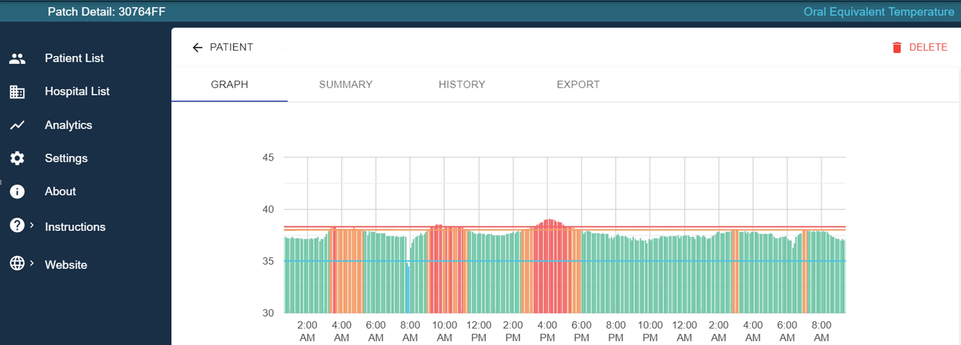

The TempTraq system was highly effective in tracking temperatures over the 72-hour period monitoring periods. Patients placed the soft pliable patches under-the-arm ‘axillary’ to record temperatures, and this is converted to a familiar oral temperature which is displayed on the TempTraq app. The wireless patches were well tolerated by the patients (reporting that they actually forgot they were wearing the patch).  Clinicians are able to monitor multiple patients remotely, (see clinic app running here), with the ability to be notified of their patients’ temperature alert thresholds being triggered. | 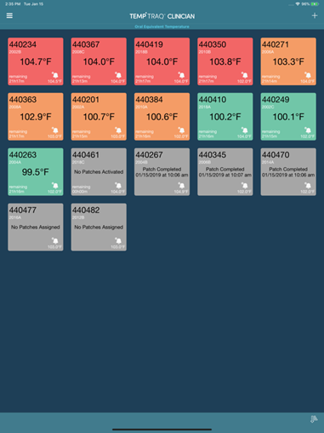

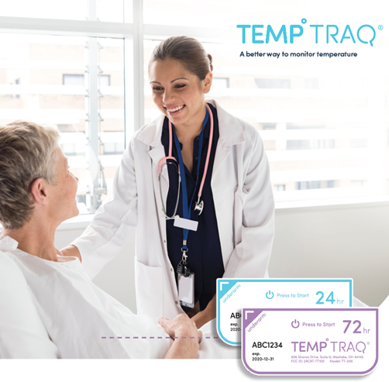 | For information about the TempTraq Continuous, Real-Time Body Temperature Monitoring System, please contact MedTach:  info@medtach.com  www.medtach.com

